Stock price co-relation using Machine learning

# Predict BankNifty value using 3 banks

First, we calculated the daily %change for BankNifty, Axis, HDFC and ICICI

Also calculated % change related to bankNifty

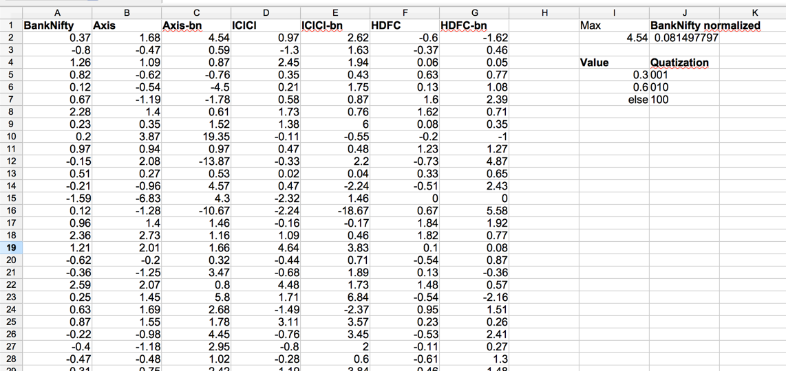

Converted into JSON for easier consumption

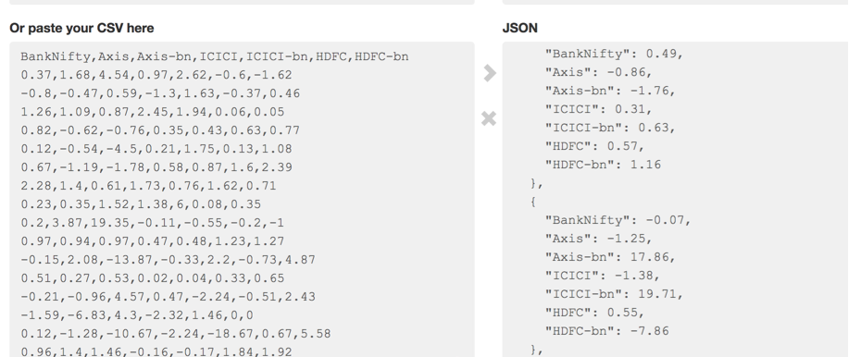

Processed this data further to give Input as follow

1: positive value

0: negative value

**Neural network to predict if BankNifty will go Up or Down** [% change will be +ve or -ve]

6, 4, 1 perceptron network [InputLayer(6), HiddenLayer(4), OutputLayer(1)]

**6 Inputs neurons**

Axis, Axis w.r.t BankNifty

HDFC, HDFC w.r.t. BankNifty

ICICI, ICICI w.r.t. BankNifty

**1 Output [BankNifty] 0 -> -ve , 1 -> +ve**

So Using Related Yearly Aggregated data for training in 20000 iterations



SUCCESS!!

# Enhancement to the Network to get %change value

**Input:** Relative %change value of 3 banks =>

= for each bank

(%change / max(3 banks %change))

**Output:** Relative %change of BankNifty

= %change / max(3 banks %change)

We need to quantize the % change value as neural network will give binary answer for output node.

**Quantization:**

**IF**

relative %change < 30, then [0, 0, 1]

relative %change < 60, then [0, 1, 0]

, Else [1, 0, 0]

Handle +ve/-ve % change:

Added 1 extra bit = 1: +ve, 0: -ve

**Example for Each Input** (4 bits): [signBit, Quantization ]

=> [1, 0, 0, 1] => +ve < 30%

=> [0, 0, 0, 1] => -ve < 30%

12, 8, 4 perceptron network [InputLayer(12), HiddenLayer(8), OutputLayer(4)]

**12 Inputs neurons [4 bits x 3 banks]**

Axis

HDFC

ICICI

**4 Output [4 bits x BankNifty] -> De-quantization to get actual % range**

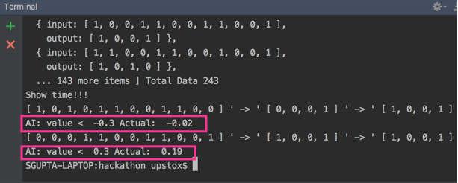

-=SP=-